# **EFS LAB**

* Login to AWS Console
* Go to EC2 and provision two EC2 instances (Amazon Linux 2 AMI) with below Bootstrap script

#!/bin/bash

yum install httpd -y

service httpd start

chkconfig httpd on

yum install amazon-efs-utils -y

* Add NFS Protocol to Inbound Rule of Security Group
* Login to two EC2 instances from Git Bash separately
  + sudo su
  + cd /var/www/html –to verify if apache is installed
  + cd
* Search for EFS and Click on it
* Click on Create File System
  + Provide the Name
  + Click on Create button

:

* Now EFS has been created
* Click on EFS Name then you can see Attach button at Top right of the screen

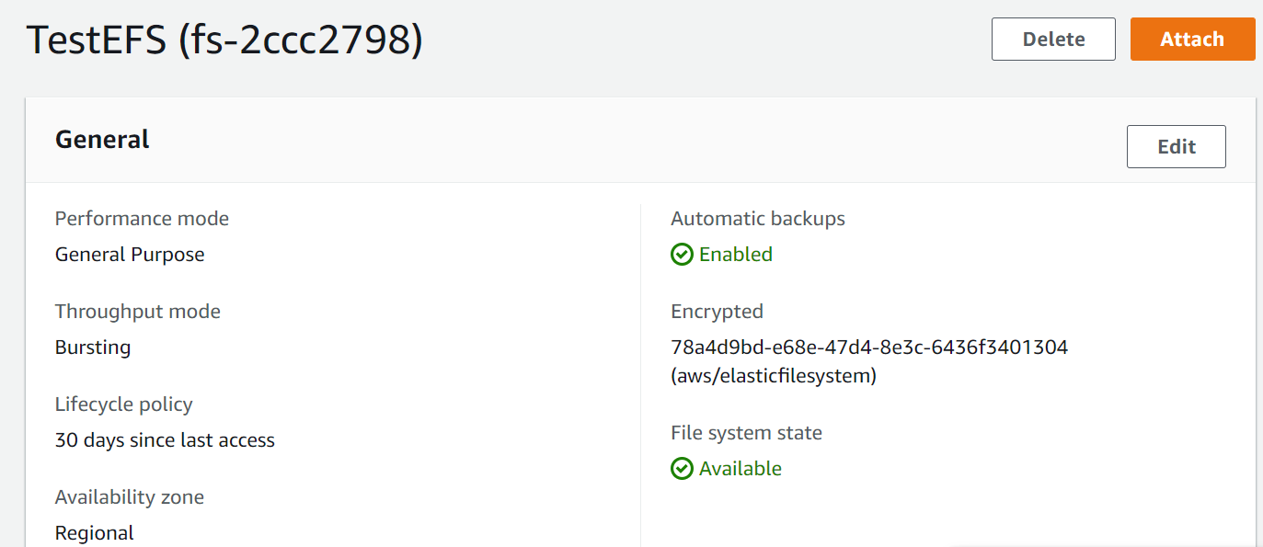

* Copy TLS Mount command similar to the one below
  + Using the EFS mount helper:
  + sudo mount -t efs -o tls fs-2ccc2798:/ efs
* and change it to
  + sudo mount -t efs -o tls fs-2ccc2798:/ /var/www/html
* then execute the above command on two EC2 Instances
* Login to EC2 instances and execute above command
* Then Create index.html in one EC2 instance and you can see this on other EC2 instance
  + sudo su
  + echo “Welcome to EFS Lab” >> /var/www/html/index.html
* Access the instances from Browser where you will be able to see the changes in index.html

**RedHat EL8**

sudo yum -y install git

sudo yum -y install rpm-build

git clone https://github.com/aws/efs-utils

cd efs-utils

sudo yum -y install make

sudo yum -y install rpm-build

sudo make rpm

sudo yum -y install ./build/amazon-efs-utils*rpm